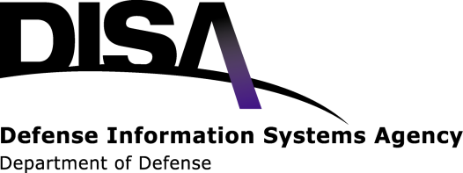HBSS 3.0 Classroom training V2
LEARNING HOST BASED SECURITY SOLUTION ESSENTIALS

Overview of the HBSS Class:
What will the students learn?
- Configure, and deploy McAfee Host IPS using ePO server 4.0
- Understand the capabilities and features of HIPS.
- Create General, Host IPS, Firewall polices and have a general understanding of Application Blocking policies
- Create exceptions to allow essential processes to continue uninterrupted
- Have an understanding of the proper way to tune policies within HBSS.
- Working knowledge of the Assets, RSD and PA modules.
- Perform security maintenance operations, administration tasks, and troubleshooting of HBSS.
- Understand how to configure HBSS to meet CTO 07-12 mandate.
This 4-day course is a System Administrator level, hands-on, open-book tested course that will cover the configuration and operation of the HBSS solution. Throughout the course, students will practice various policy configurations using VM-ware to simulate a student’s environment. Students will gain understanding of concepts and skills necessary to perform daily administration of HBSS in their network environment.
Prerequisites for HBSS 3.0:
1. HBSS administrator or equivalent
2. Knowledge of the CTO 07-12 requirements
3. Network and System administrator background
HBSS 3.0 Class Administrative Items:
Schedule:
- Tuesday-Friday from 8am-5pm
- Lunch break from 11:30-12:30
Dress Code: Business Casual
Homework: To review the days materials and answer review questions
Test:
- 1 Hour Open Notebook Test on Friday.
- 35 Questions Students must get 25 Correct
Evaluations: Class evaluation forms will be handed out after class to be completed prior to leaving
Certificate: Tests will be graded while student is filling out the evaluation form. Student will receive a certificate before they leave class if they pass the test.
Course Outline:
- Introduction to HBSS
- Installation
- Web-based Console and Dashboards
- ePO Queries
- ePO System Tree
- ePO Sorting and Tagging
- ePO Polices and Policy Catalog
- ePO Users and Permission Sets
- McAfee Agent
- ePO Repositories
- ePO Notifications
- Rogue System Detection
- HIPS_Windwos Client
- HIPS Ceneral Policy
- HIPS IPS Policy
- HIPS Firewall Policy
- HIPS Application Blocking Policy
- Solairs/ Unix Client
- Assets Module
- Device Control Agent
- DLP User Assignments
- Device Control
- DLP Reporting
- Policy Auditor

